**Episode 1:** Cloud Computing, High Availability, Scalability, Elasticity, Agility, Fault Tolerance, and Disaster Recovery

**Episode 2:** Principles of economies of scale

**Episode 3:** Capital Expenditure (CapEx) vs Operational Expenditure (OpEx) and their differences

**Episode 4:** Consumption-based model

**Episode 5:** IaaS, PaaS, SaaS and their differences

**Episode 6:** Public, Private, Hybrid cloud and their differences

**Episode 7:** Azure Regions and Availability Zones

**Episode 8:** Azure Resource Groups and Resource Manager

**Episode 9:** Azure Compute Services | Virtual Machine, VM Scale Set, App Service, Functions, Container Instances, Kubernetes Service

**Episode 10:** Azure Networking Services | Virtual Network, Load Balancer, VPN Gateway, Application Gateway, CDN

**Episode 11:** Azure Storage Services | Blob, Disk, File and Archive

**Episode 12:** Database Services | Cosmos DB, SQL Database, SQL DB for MySQL and PostgreSQL, SQL Managed Instance

**Episode 13:** Azure Marketplace

**Episode 14:** Azure IoT Services | IoT Hub, IoT Central, Azure Sphere

**Episode 15:** Azure Big Data and Analytics Services | Synapse Analytics (SQL Datawarehouse), HDInsight, Databricks

**Episode 16:** Azure Artificial Intelligence (AI) Services | Machine Learning Studio and Service

**Episode 17:** Azure Serverless Computing Services | Functions, Logic Apps, Event Grid

**Episode 18:** Azure DevOps Solutions | Azure DevOps, DevTest Labs

**Episode 19:** Azure Tools | Portal, PowerShell, CLI and CloudShell

**Episode 20:** Azure Advisor

**Episode 21:** Security Groups | NSG and ASG | Network Security Groups and Application Security Groups

**Episode 22:** User-defined Routes (UDR)

**Episode 23:** Azure Firewall

**Episode 24:** Azure DDoS Protection

**Episode 25:** Azure Identity Services | Identity, Authentication, Authorization & Azure AD

**Episode 26:** Azure Security Center and usage scenarios

**Episode 27:** Key Vault

**Episode 28:** Role-Based Access Control (RBAC)

**Episode 29:** Resource Locks

**Episode 30:** Tags

**Episode 31:** Azure Policy

**Episode 32:** Azure Blueprints

**Episode 33:** Cloud Adoption Framework

**Episode 34:** Core tenets of Security, Privacy, and Compliance

**Episode 35:** Cost Affecting Factors

**Episode 36:** Cost Reduction Methods and Pricing, TCO Calculators

**Episode 37:** Azure Cost Management

**Episode 38:** Azure Service Level Agreement (SLA)

**Episode 39:** Service lifecycle in Azure

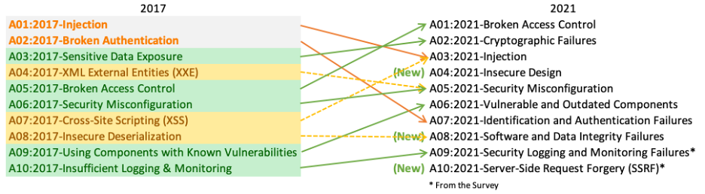

Locally Redundant Storage (LRS)

Geo-Redundant Storage (GRS)

Zone-Redundant Storage (ZRS)

Geo-zone-redundant Storage (GZRS)

Read-Access Geo-Redundant Storage (RA-GRS)